 Project Report Template

TITLE: JOB APPLICATION TRACKING SYSTEM

**1. INTRODUCTION**

**1.1 Overview**

**Create a CRM Application which helps the applicant to track the No. of jobs he applied and helps him to find the job posted by the various recruiters, find the best attributes to be involved to run the process in a smooth way and easily to track.**

**1.2** **Purpose**

* **It is useful for the employers to manage the job applications.**
* **It saves time for the employers.**
* **It is useful for employers to find the person with the required skill they are expecting to have.**
* **It is useful for short list the resume.**
* **Helps the candidate to identify the job related to their skills.**
* **It helps to apply for multiple jobs at one time.**

**2. Problem Definition & Design Thinking**

**2.1 Empathy Map**

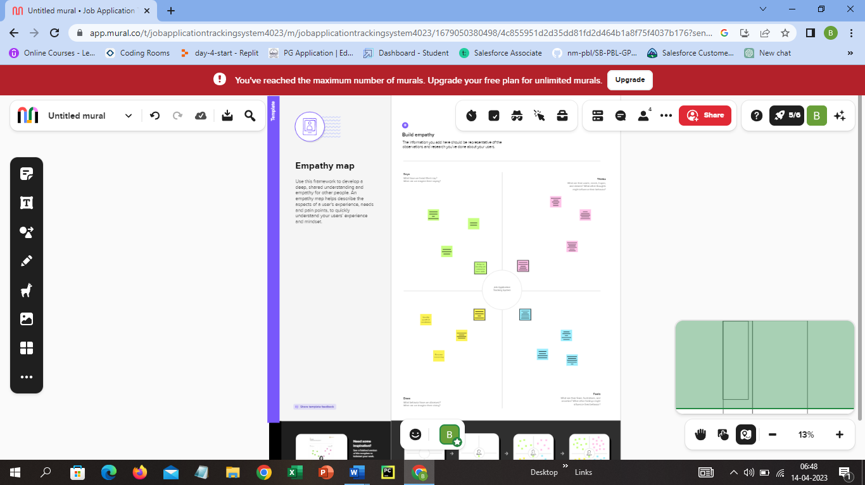

**2.2 Ideation & Brainstorming Map**

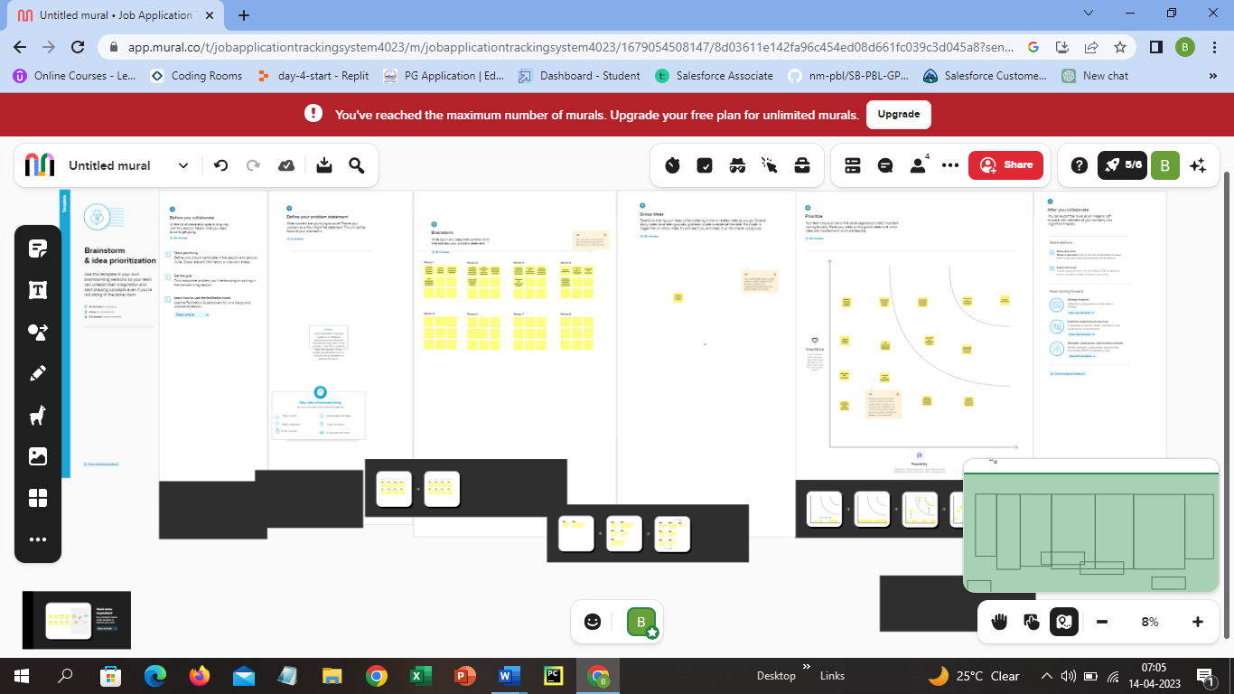

**3.** **RESULT**

3.1 Data Model:

|  |  |
| --- | --- |
| **Object name** | **Fields in the Object** |
| Recruiter | |  |  | | --- | --- | | Field label | Data type | | Job title | Text | |
| Jobs | |  |  | | --- | --- | | Field label | Data type | | Recruiter | Master-detail Relationship | | Description | Text |  |  |  | | --- | --- | | Location | Text | |

**3.2 Activity & Screenshot**

**Milestone 1- Salesforce:**

**Activity1: Creating a Salesforce Developer Org**

**To create a Salesforce Developer Org, search Developer.salesforce.com and enter the details required and click sign me up and we will receive a mail to verify account and a new password can be created click save. Search login.salesforce.com and using username and password we can log in to salesforce and the following setup page will be available.**

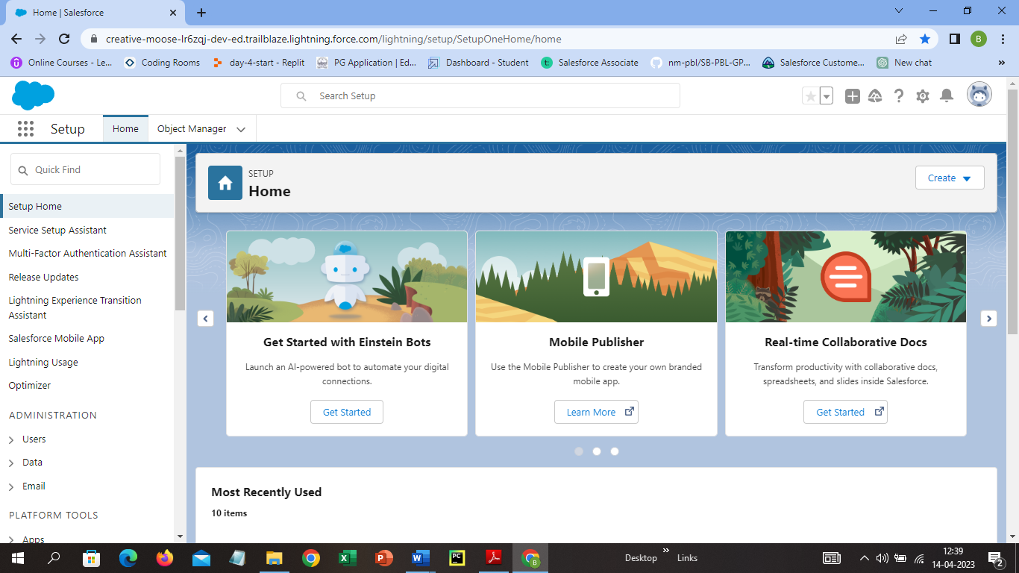

**Milestone 2-Object:**

**Activity 1: Create a custom object for Recruiter**

**From Salesforce home page, click gear icon and select setup and select object manager and click create and select custom object and fill the details of label and plural label as Recruiter and Recruiters. Record name as Recruiter Number and data type as Auto Number and display format as REC-{0000} and starting number as 1. In Optional Features select the following Allow Reports and Track Field History and ensure Deployed is selected in the Deployment status section. Select Allow search in search status and in object creation option select add notes and attachments related list to default page layout and leave everything as it is and click save.**

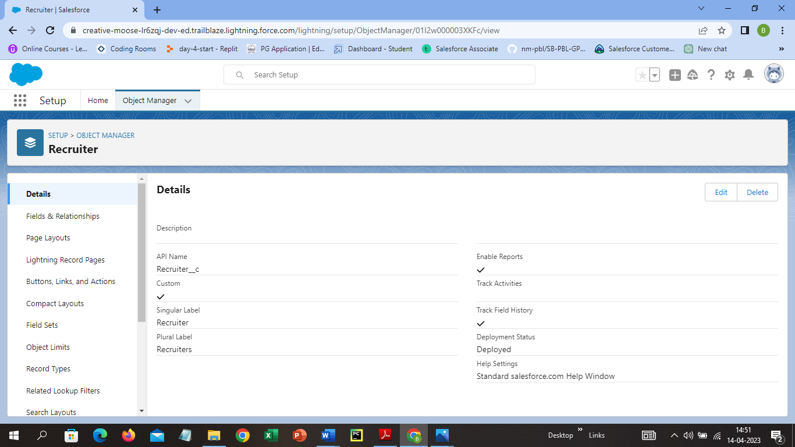

**Activity 2:**

**Follow the steps in the Activity 1 to create the following custom object.**

**Jobs:**

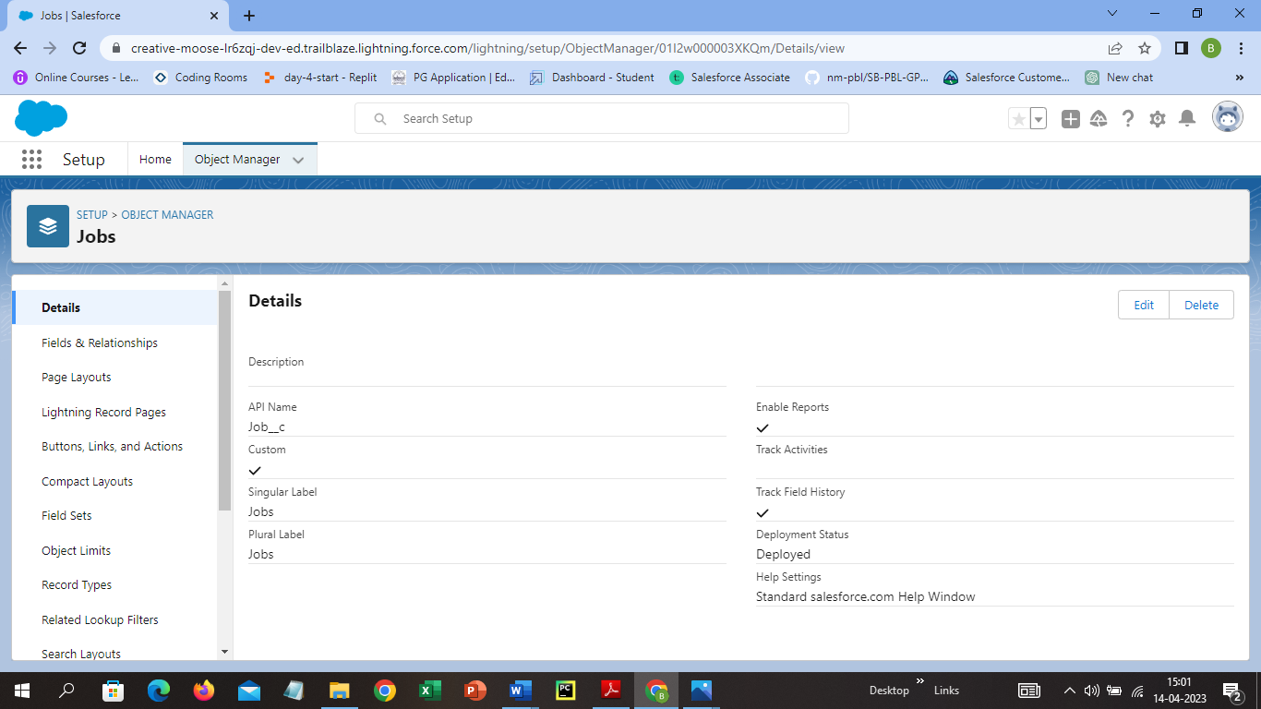

Candidate:

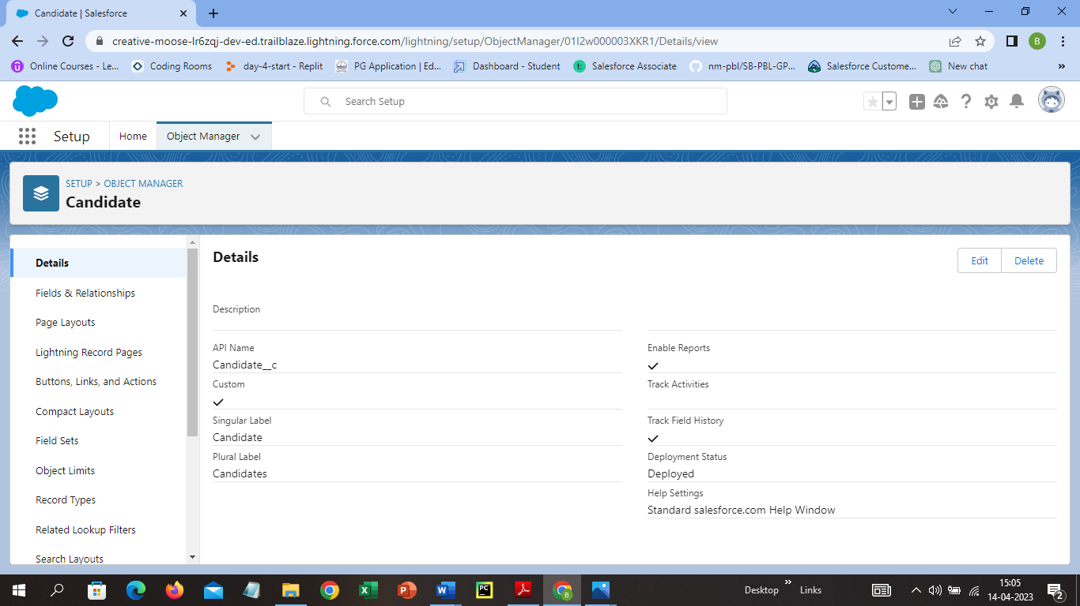

Job Application:

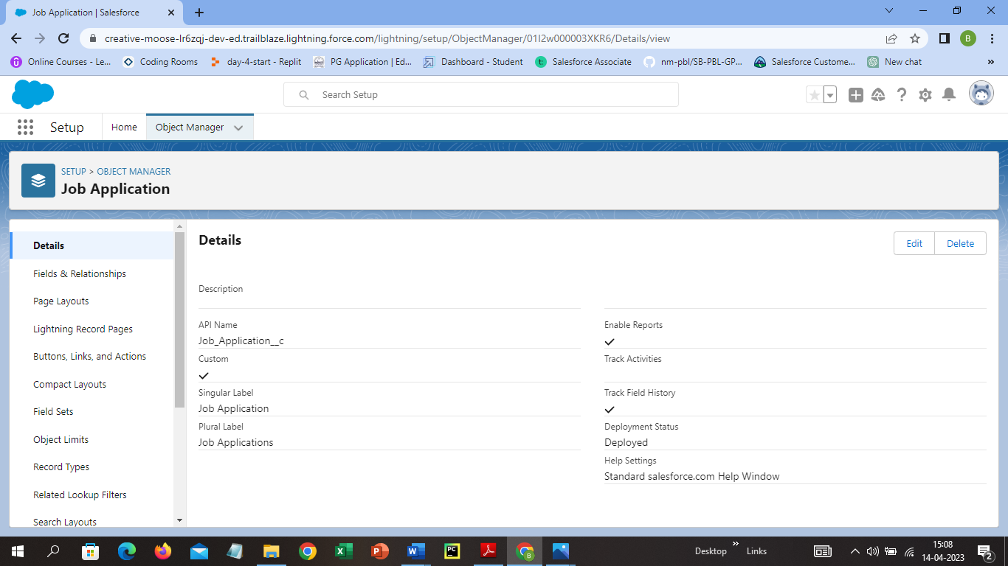

Tab:

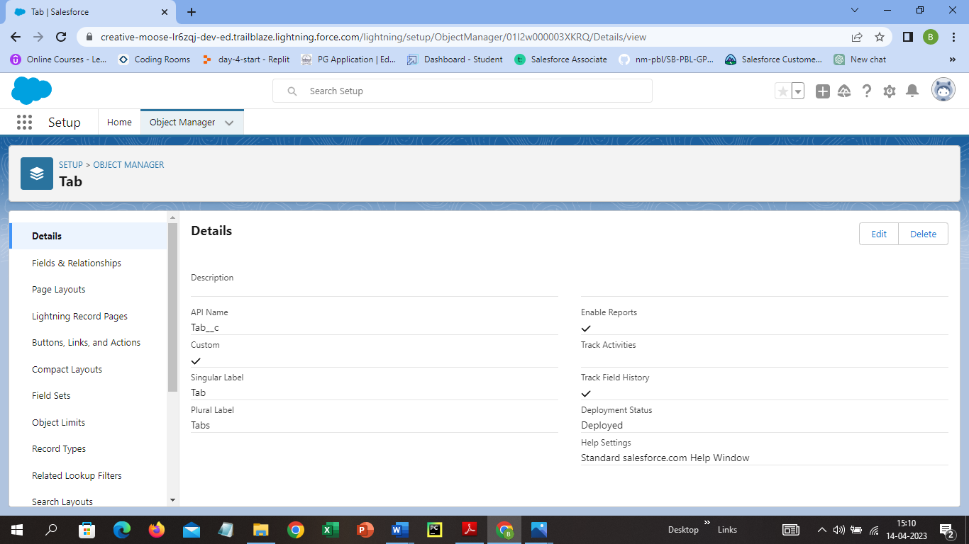

**Milestone 3- Fields:**

**Activity 1: Create the custom fields**

**Click on Recruiter object, select fields and relationship from left navigation and click new. Select the Data type as Text and click next and for field label enter Job title and for length enter 30 and click next, next and save.**

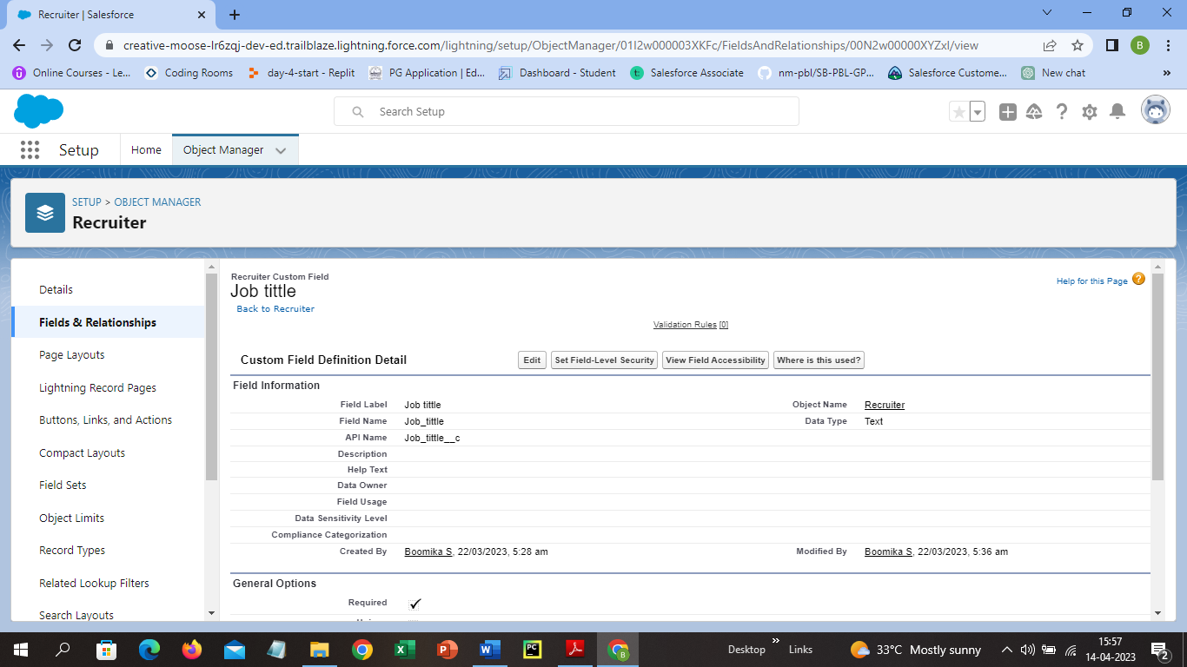

**Activity 2: Creation of Master-detail relationship**

**Click on Jobs object from the Object Manager and select fields and relationship from the left navigation bar and click new. Select the data type as Master-detail relationship and click next, choose the related object as Recruiter and click next and enter the label and name for the lookup fields as Recruiter and click next, next and save.**

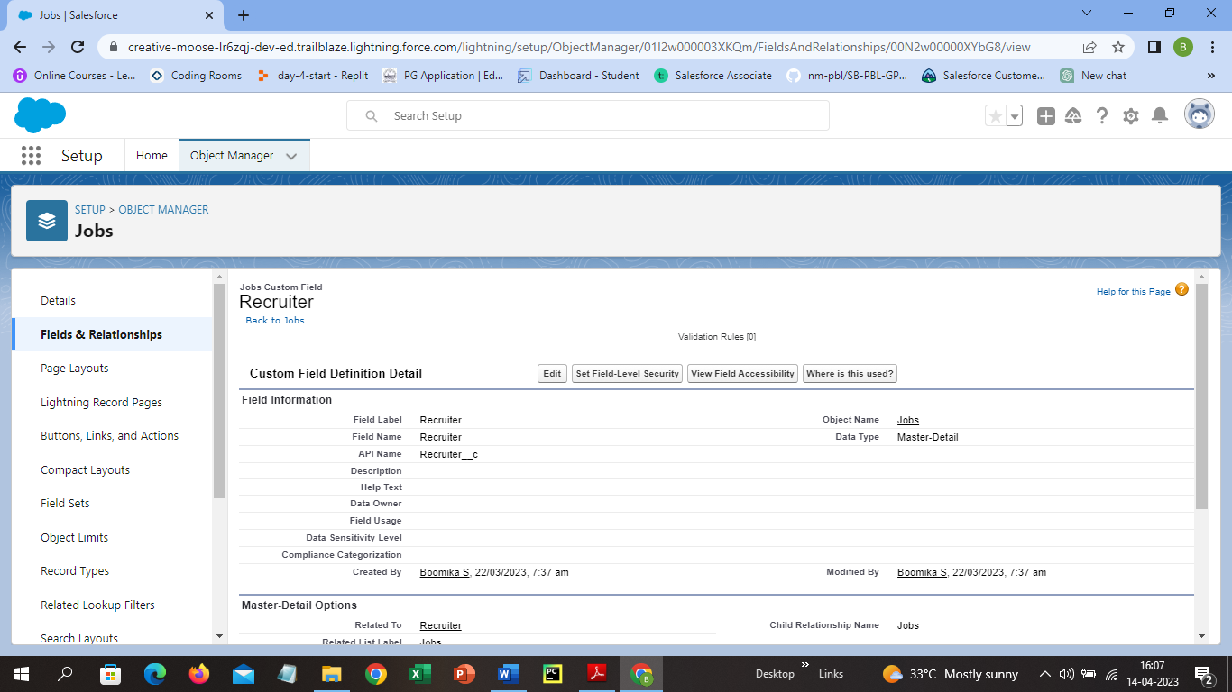

**Activity 3: Create a new custom field**

**Follow the same procedure in the Activity 2 and for data type select Text Area and for field label select Description.**

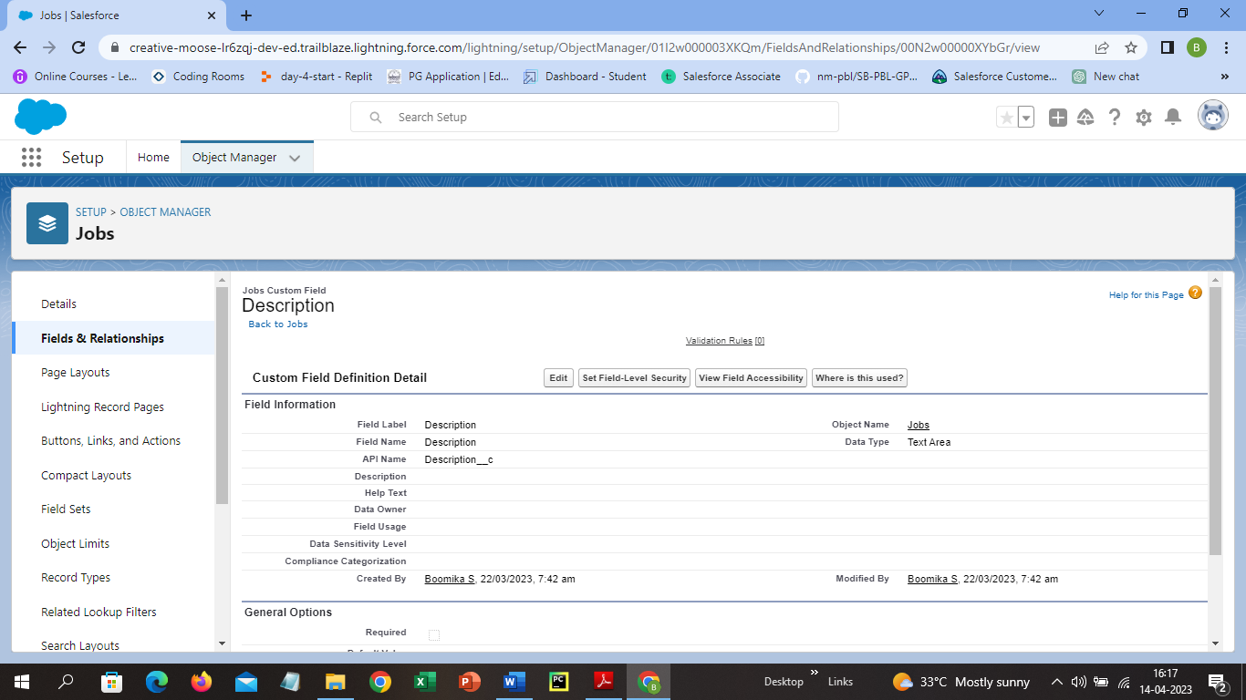

**Activity 4: Create a new custom field**

**Follow the same procedure in the Activity 2 and for data type select Text and for field label select Location.**

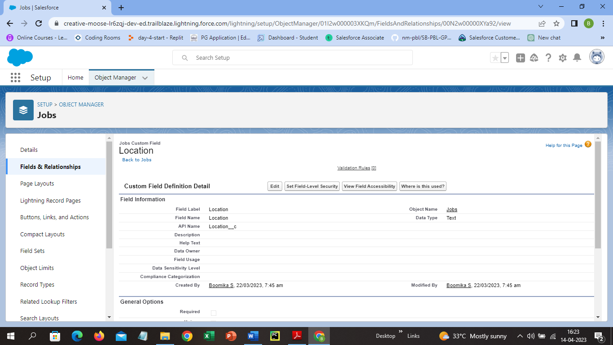

**Milestone 4-Tab:**

**Activity 1: Create a tab**

**Select Tabs in the quick box and click new from custom object tabs and select the object as Recruiter and select a tab style, that is visible and click save.**

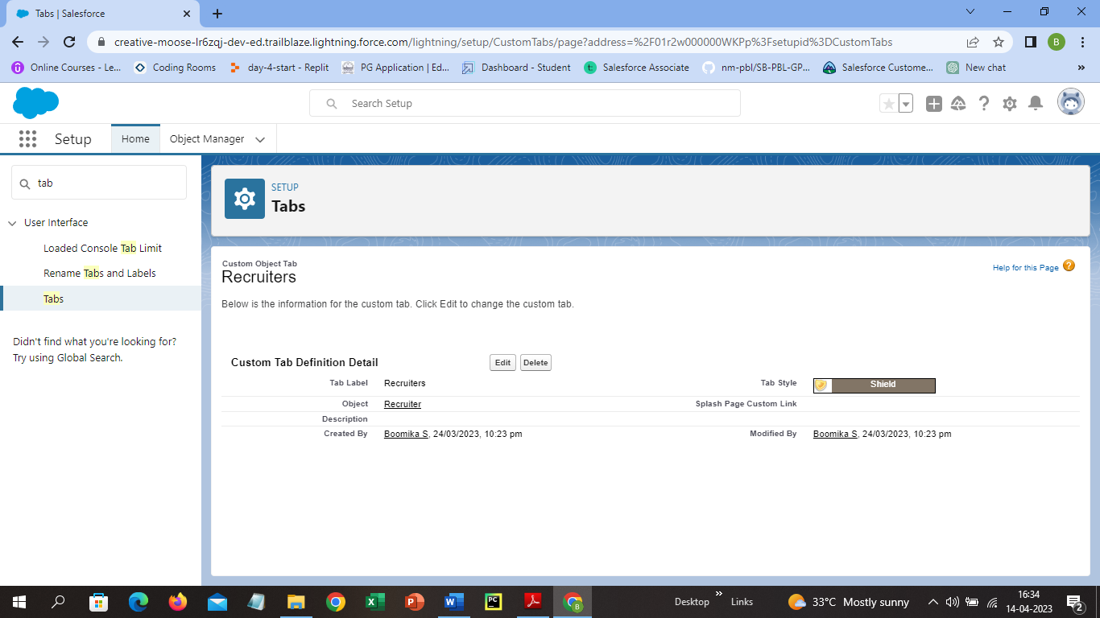

**Milestone 5- Profile:**

**Activity 1: Create a custom profile**

**Select profiles from the quick find box and click clone for the profile name standard user and for profile enter Recruiter and click save.**

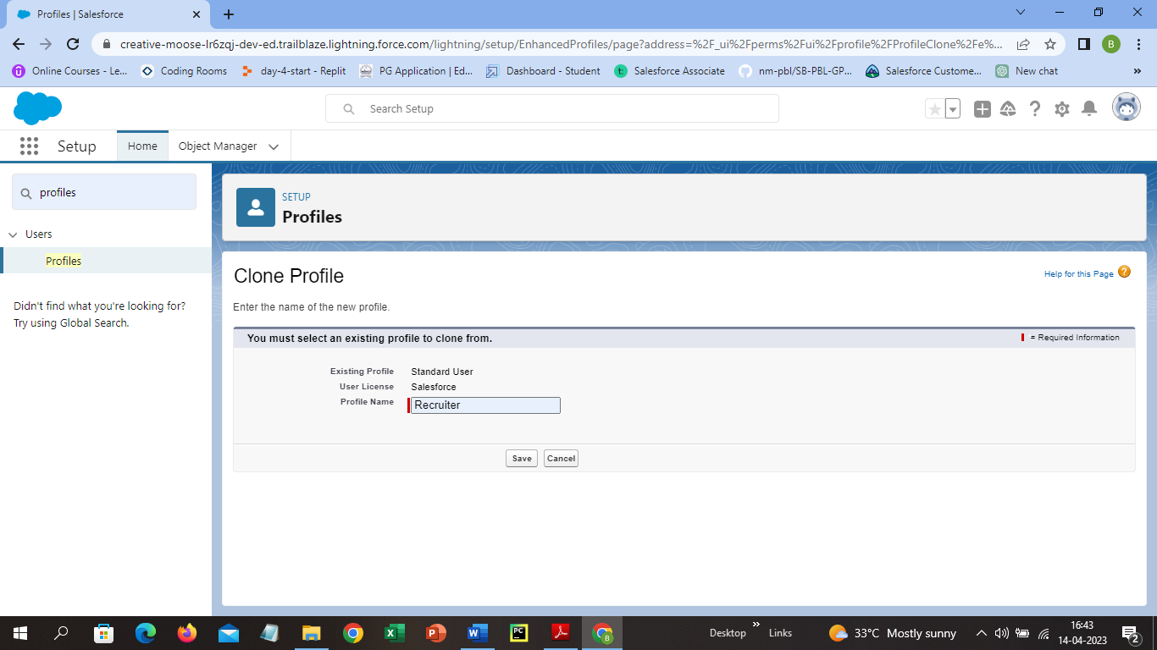

**Activity 2: Create a profile with the profile name as “Sales Manager”.**

**Follow the same procedure in the Activity 1 and for profile name enter Sales Manager.**

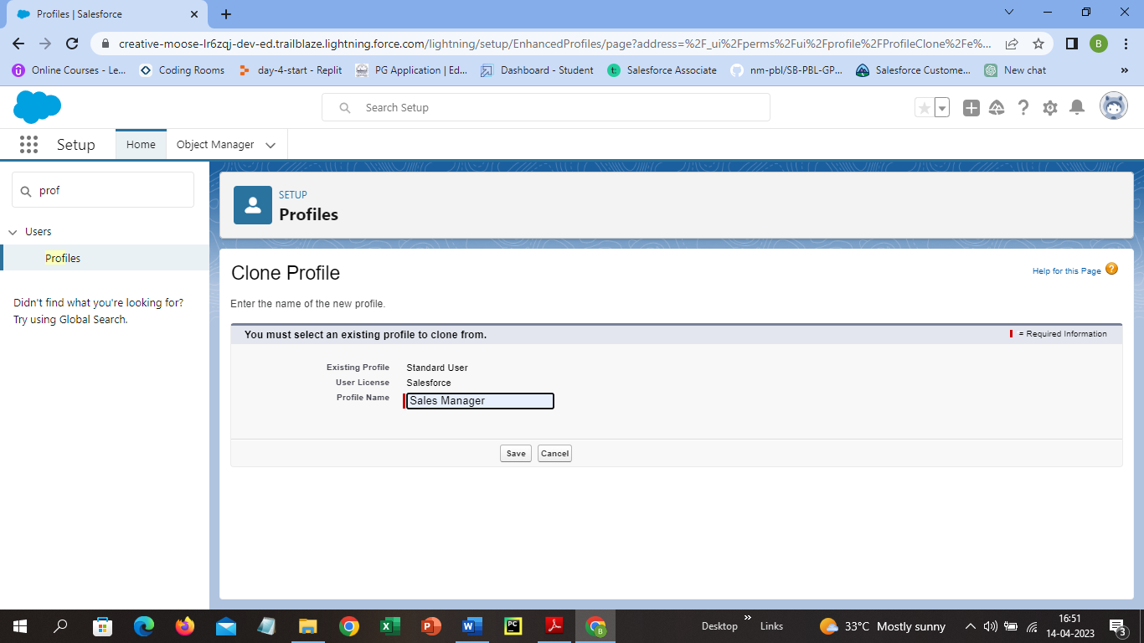

**Milestone 6-User:**

**Activity 1: To Create a user**

**Select Users from quick find box and click New User, enter the first name and last name as Hr and Manager, enter username and email. Select User License as Salesforce Platform and profile as Standard Platform User and click save.**

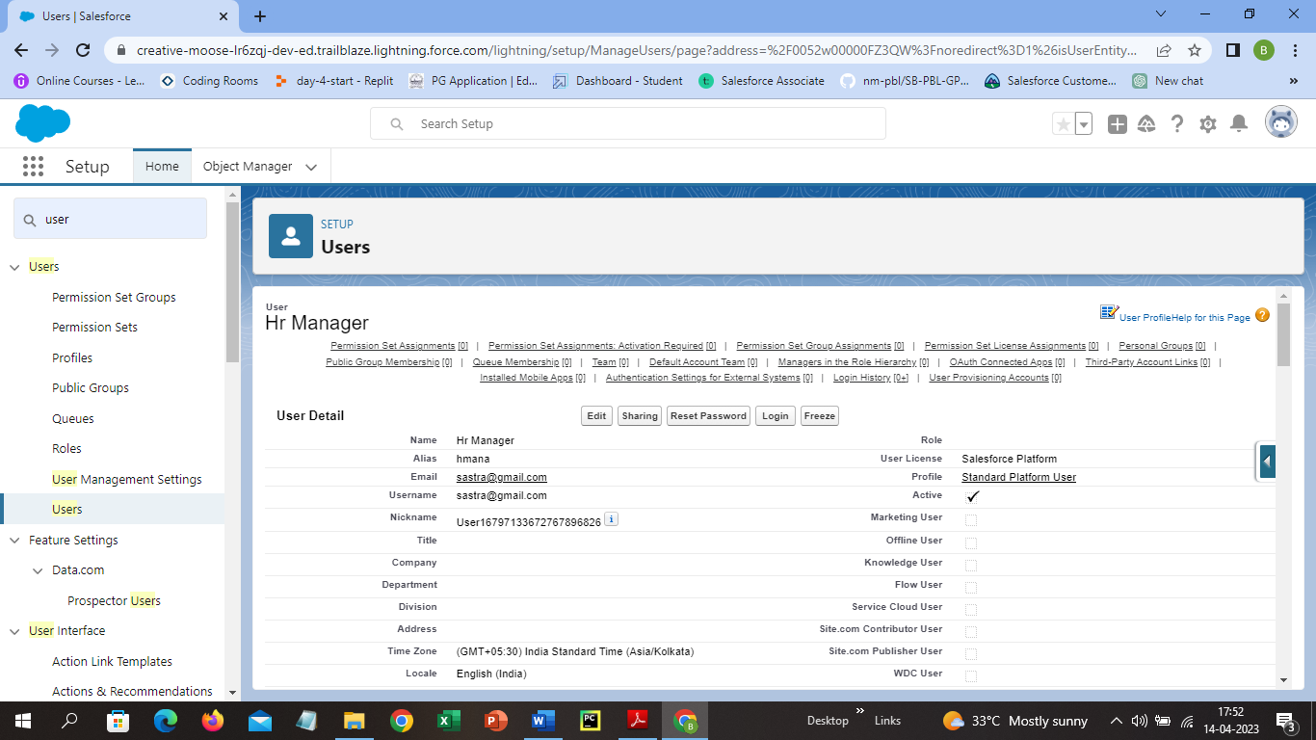

**Activity 2: Create a user with a username as “Ganesh Gelli”, and assign him the sales Manager profile.**

**Follow the same procedure in Activity 1 and for Username enter Ganesh Gelli and assign the profile as Sales Manager.**

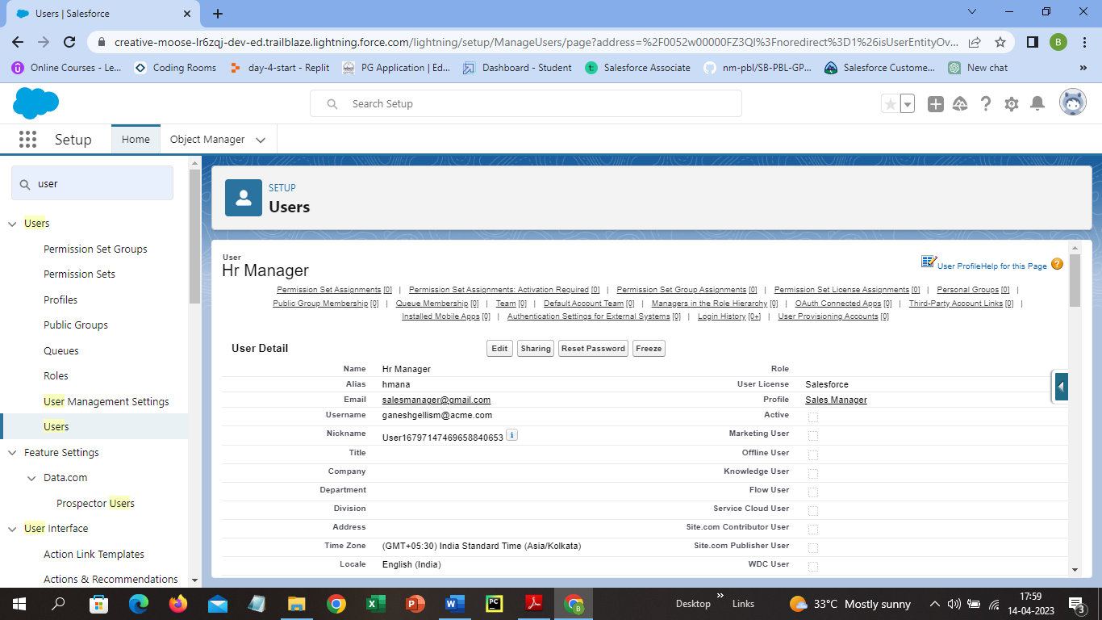

**Milestone 7-Sharing Rules:**

**Activity 1: Create a sharing rule**

**Select Sharing Settings from the quick find section and scroll down to Candidate Sharing Rules and click new. Enter Label as Candidate and select based on criteria in rule type. In records to be shared select field as Candidate and Operator as equal and value as true. In users to share with section select Roles and select Hr Manager and in the level of access for the users select Read/Write, click save.**

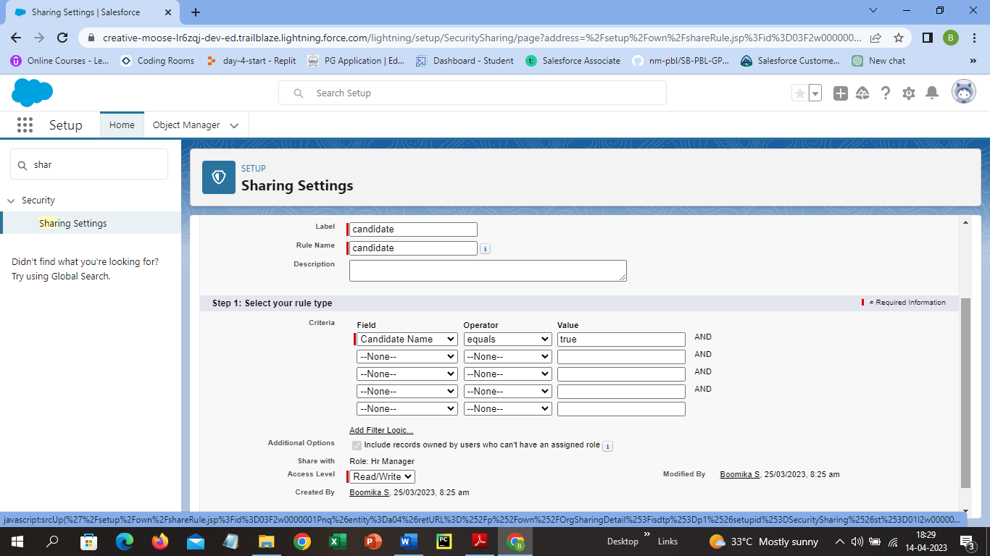

**Activity 2: Create a Sharing Rule to Share the records of Job Application to Hr Manager with the Access of Read/Write.**

**Follow the same procedure in Activity 1 and enter the label as Job Application and share the records with Hr Manager with Access to Read/Write.**

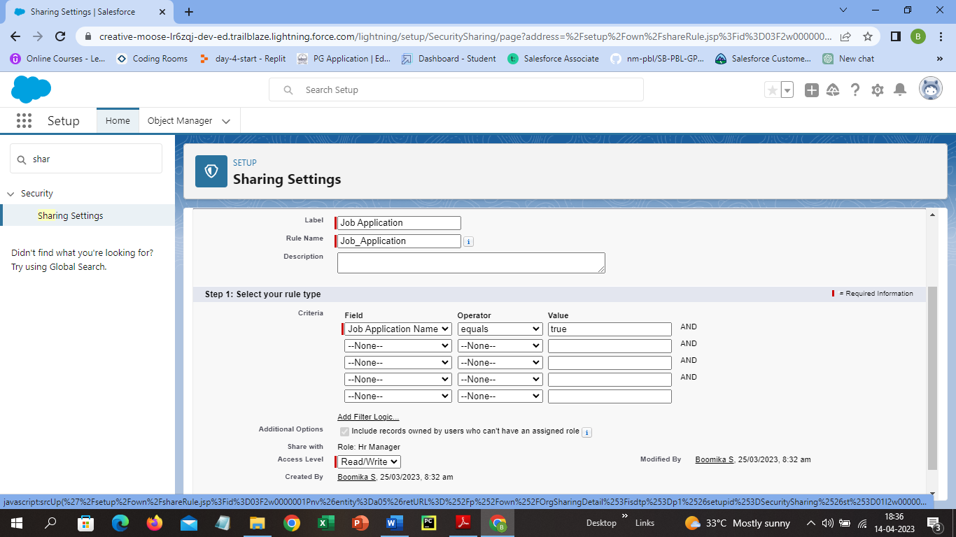

**Milestone 8-Reports:**

**Activity 1: Create a report**

**Select Report from the App launcher and click new report and select the category that has accounts and contacts and select report type has accounts and select start report and in the filter pane select all accounts to show me and all time is created, in outline pane select Rating and in group columns select Account Name and in the columns section add Type and Billing city and save the report as Label Name and the folder as public folder and save the Report.**

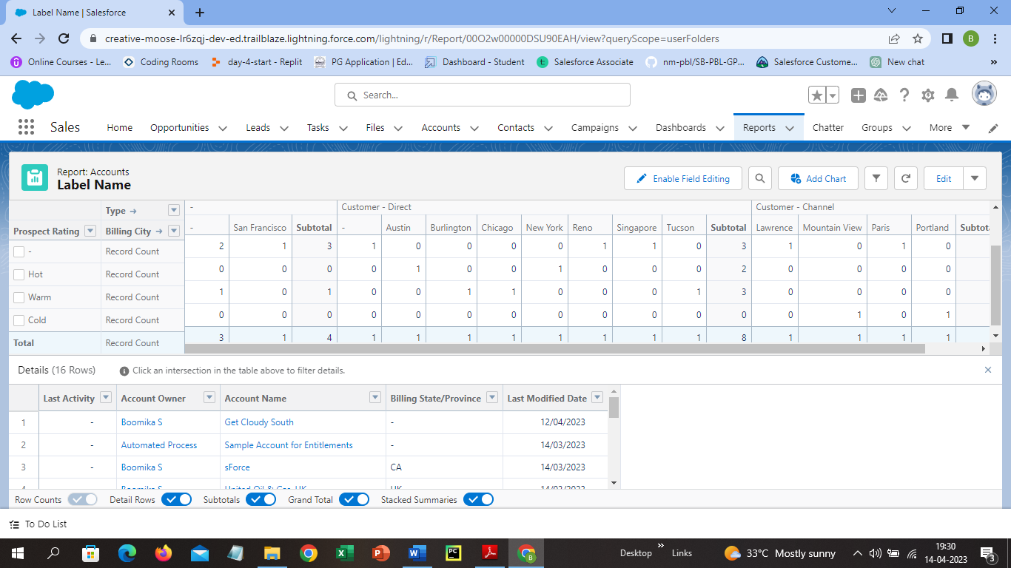

**Activity 2: Create a Report using the Objects Jobs, Candidate and Job Application.**

**Follow the procedure from the Activity 1 and the Report is as follows.**

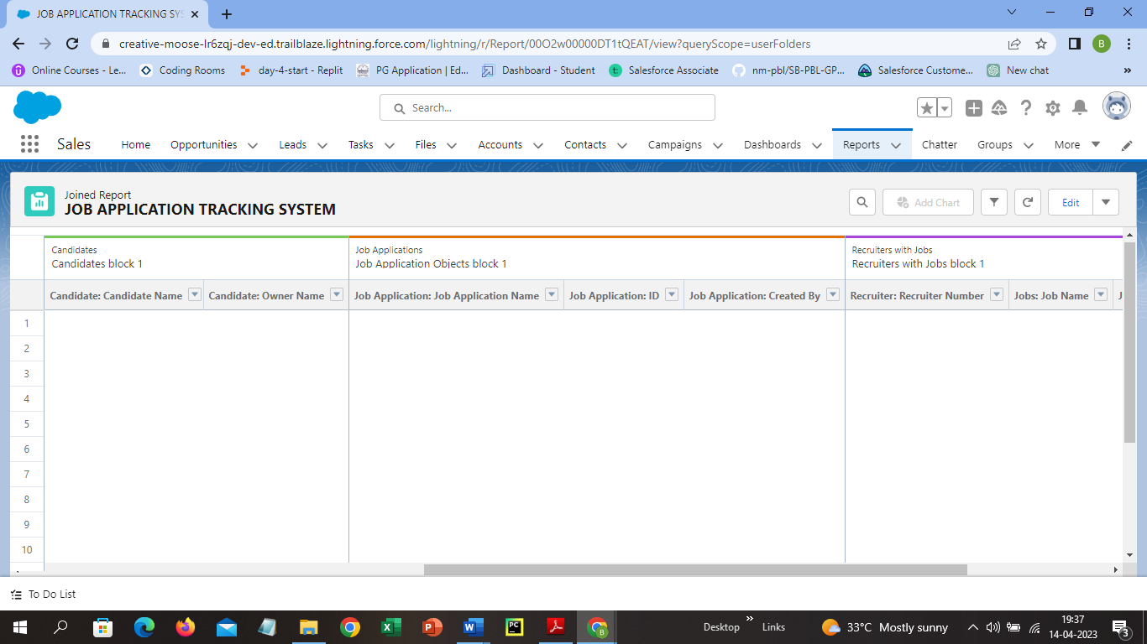

1. **Trailhead Profile Public URL**

**Team Lead -** **https://trailblazer.me/id/boomi28**

**Team Member 1 - https://trailblazer.me/id/sumcs**

**Team Member 2 - https://trailblazer.me/id/sangs43**

**Team Member 3 – https://trailblazer.me/id/gowsk3**

1. **ADVANTAGES & DISADVANTAGE**

**ADVANTAGES:**

* **It helps the organizations and employers to track the application received.**
* **It saves a lot of time since it can automate the many aspects of recruitment process.**
* **It helps the employers to communicate more efficiently with the candidates.**
* **It is also helpful for the future hiring process.**

**DISADVANTGES:**

* **It can be very expensive for small companies.**
* **It requires training for the users to use so it take lot of time and resources.**
* **It is a software program it can have some technical issues and it can slow down the recruitment process.**
* **It can sometimes misread the resumes in pdf format.**

1. **APPLICATIONS**

* **Job posting and advertising**
* **Resume screening**
* **Candidate communication**
* **Interview scheduling**
* **Candidate assessment**
* **Data analysis**

1. **CONCLUSION**

**Job Application Tracking System is very helpful for the employers and organizations it reduces the time and makes the recruitment process simple. Job Application Tracking System are essential for any organizations looking to improve their recruitment process and find the right candidate more effectively.**

1. **FUTURE SCOPE**

**The future scope of job application tracking system is expanding and it includes AI to automate the aspects of the recruitment process. The potential to improve the accuracy and effectiveness in the recruitment process.**